**Phase-2: Org Setup & Configuration**

This phase focuses on setting up the Salesforce environment to support NGO operations, donation tracking, and impact management. It ensures proper configurations, security, and user access to align with organizational processes.

**1. Salesforce Editions**

Salesforce offers multiple editions, each with varying features. Choosing the right edition is crucial for NGO operations.

**Step:**

1. Navigate to **Setup → Company Settings → Company Information**.
2. Check the **Salesforce Edition** field.

**Recommendation for NGO Project:**

* **Enterprise edition** provides custom objects, workflows, API access, and automation rules, which are crucial for an AI-powered system that tracks donations and impact metrics.
* **Nonprofit Success Pack (NPSP)** which Built on Enterprise Edition; ideal for NGOs.

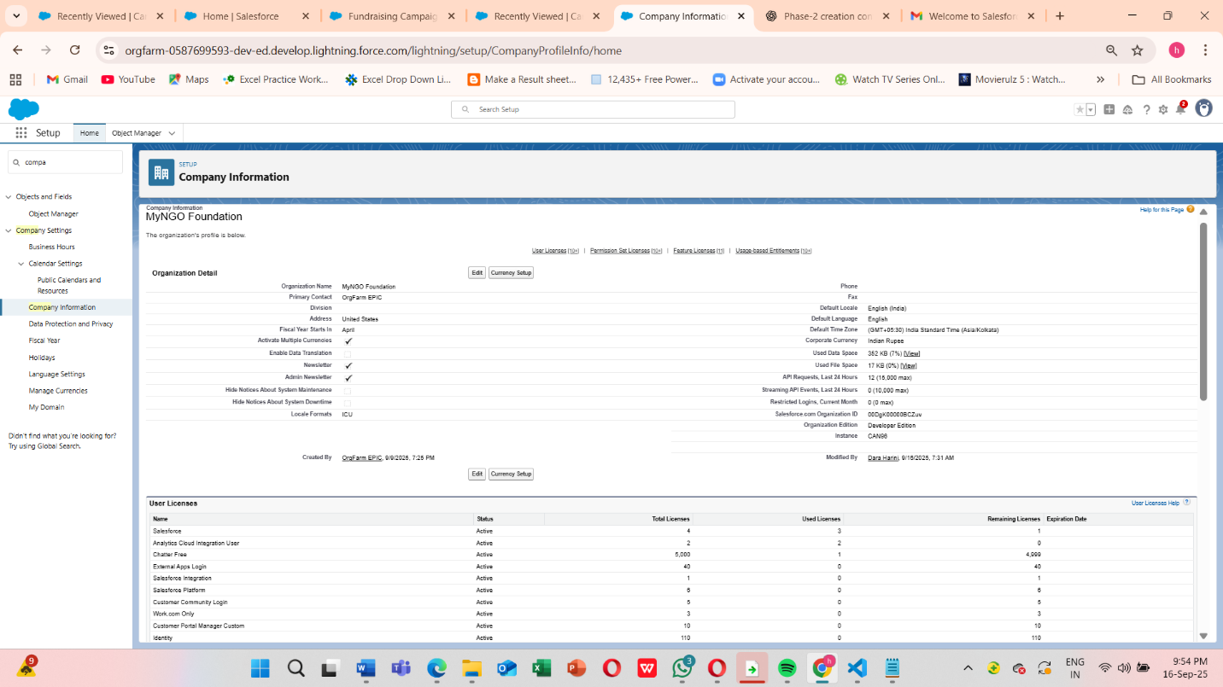

**2. Company Profile Setup**

Set up your company information to ensure correct branding and reporting.

**Steps:**

1. **Setup → Company Settings → Company Information**.
2. Fill in:
   * **Company Name**: “AI-Powered NGO Donation System”
   * **Primary Contact**
   * **Default Locale, Time Zone**
   * **Default Currency** (important if your NGO accepts multiple currencies)
3. Save changes.

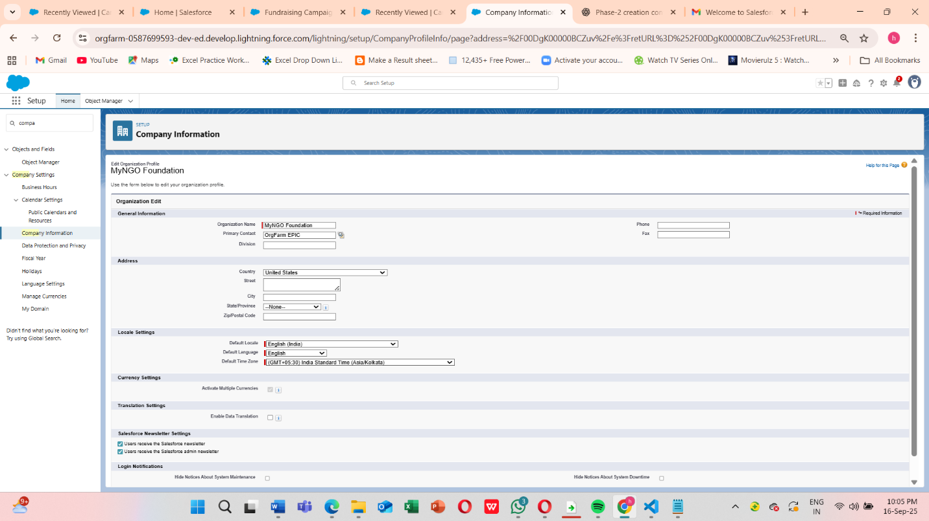

Ensures that reports, dashboards, and automated processes show accurate and localized data and Accurate company info ensures correct reporting, date/time handling, and currency calculations.

**3. Business Hours & Holidays**

NGOs often have operations that need accurate service availability settings (for donor support, case management, etc.).

**Steps:**

1. Go to **Setup → Company Settings → Business Hours**.
2. Click **New** → Define standard hours for donor support (e.g., Mon-Fri, 9 AM–6 PM).

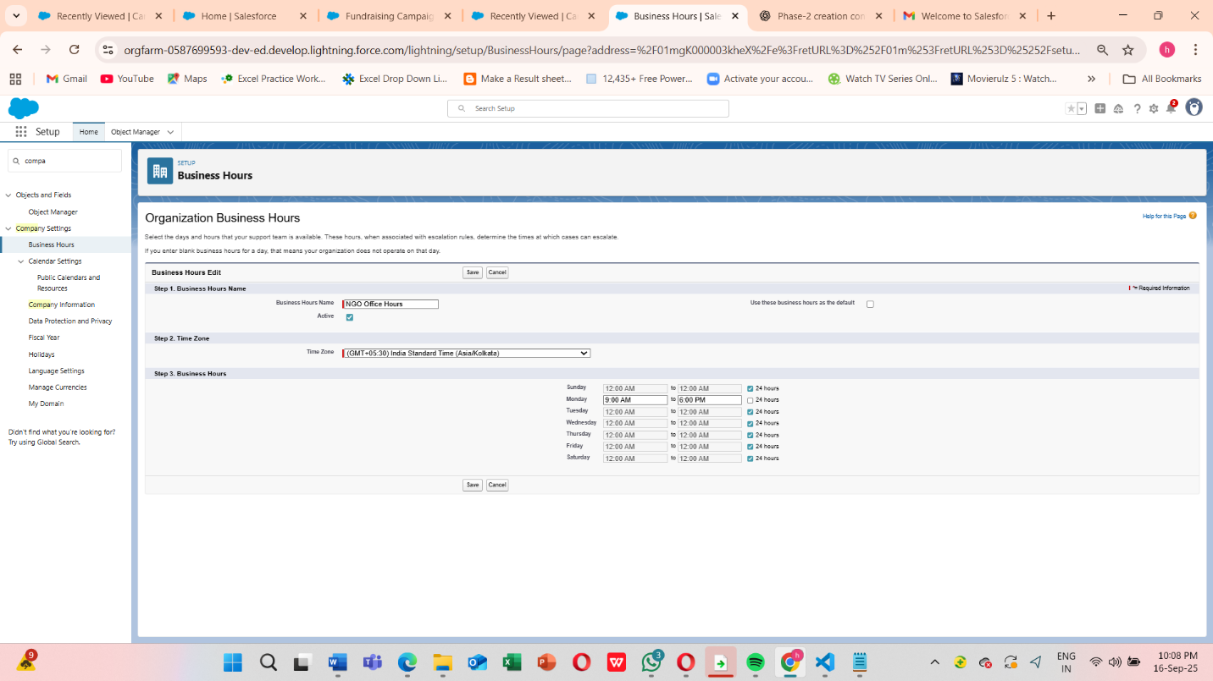

1. Setup → Holidays
2. Click New Holiday -> Add NGO-specific holidays (e.g., Foundation Day, Public Holidays)

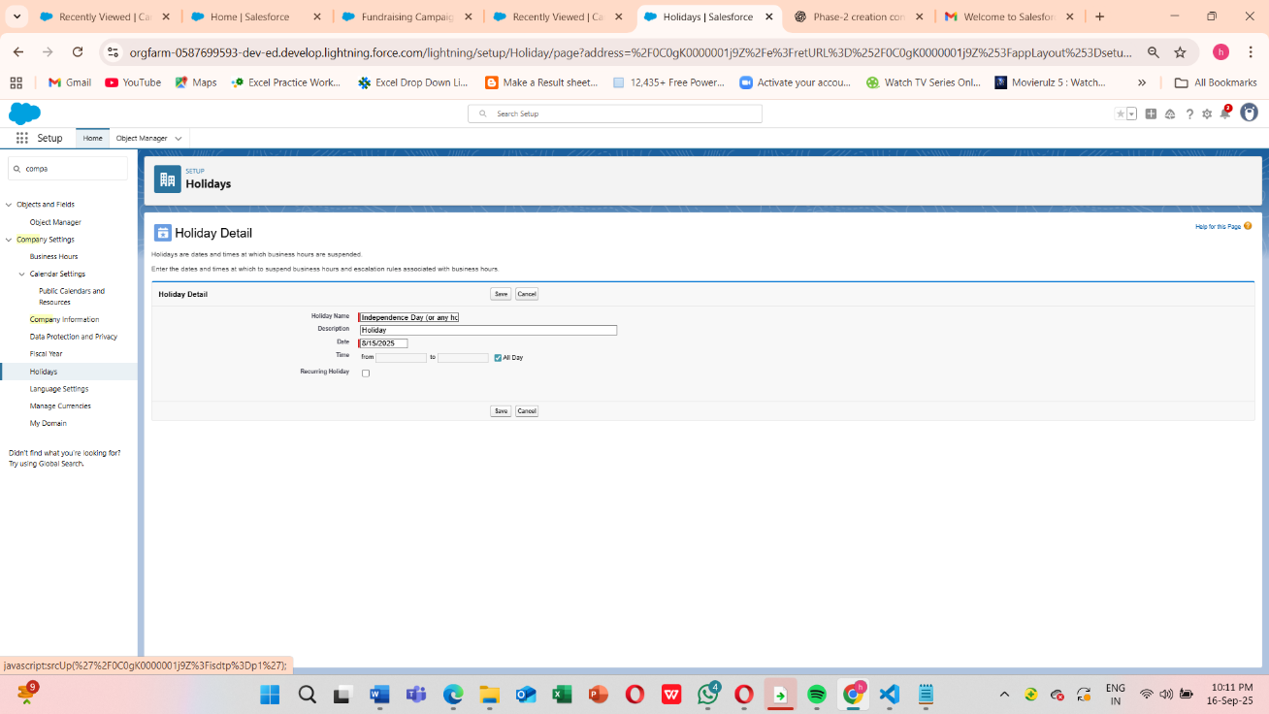

Business Hours page with list view showing “NGO Operating Hours”. Holidays page listing multiple entries.

* Ensures that **case escalation rules, automated workflows, and AI notifications** respect business hours.

**4. Fiscal Year Settings**

This controls reporting and financial tracking for donations.

**Steps:**

1. **Setup → Company Settings → Fiscal Year**
2. Choose either **Standard Fiscal Year** (Jan–Dec) or **Custom Fiscal Year** (e.g., NGO operates Apr–Mar).
3. Save changes.

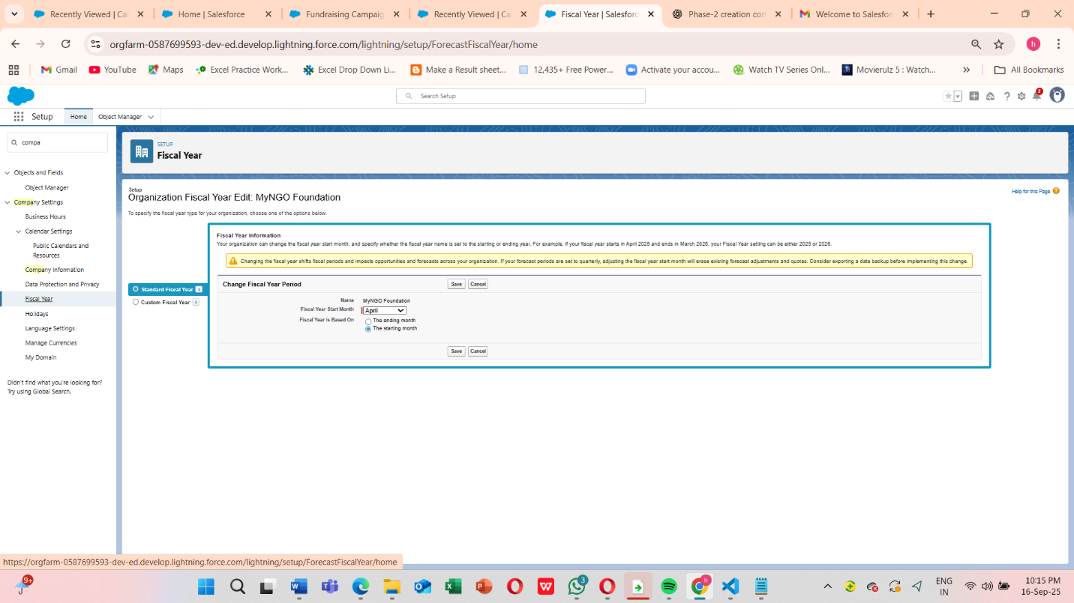

Fiscal Year page showing the selected start month and period.

Accurate **donation reports, grant tracking, and AI predictions** rely on correct fiscal periods.

**5. User Setup & Licenses -> Creating Role Hierarchy**

Users must have proper licenses to access Salesforce features.

**Steps:**

1. **Setup → Users → Users → New User**
2. Assign:
   * **Full Name**
   * **Email**
   * **Role**
   * **Profile**
   * **License Type** (Salesforce Platform / Salesforce / Chatter Only)
3. Save and send **login credentials**.

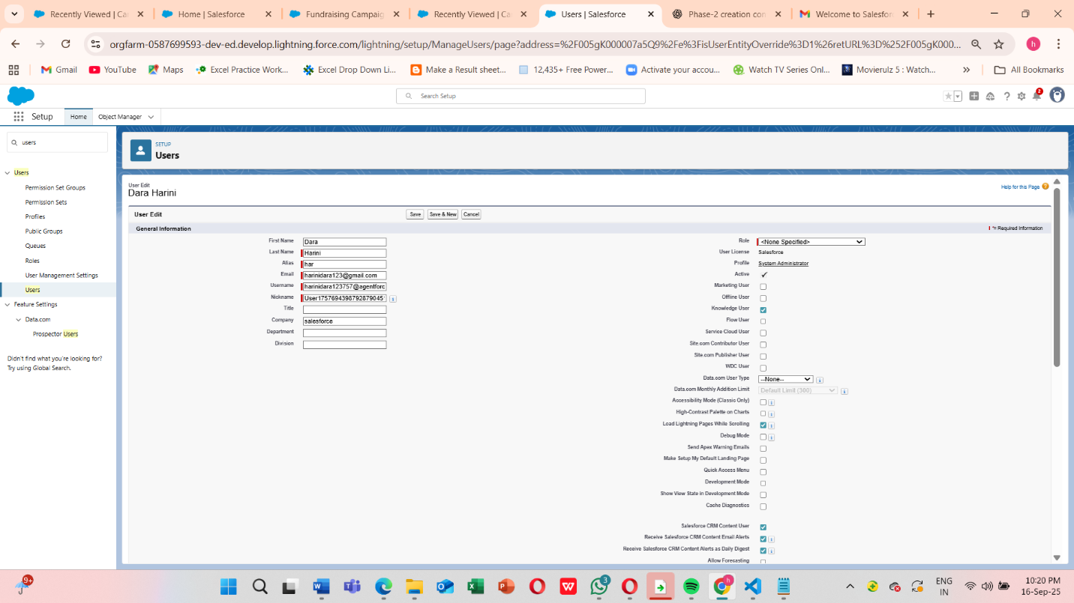

Licenses define **permissions, access to objects, and AI features**. For example, a fundraiser may need full Salesforce license, while a volunteer coordinator may need only platform license.

New User” form with fields for Name, Email, Profile, Role, and License.

**6. Profiles**

Profiles define **baseline permissions** for objects, fields, and tabs.

**Steps:**

1. **Setup → Users → Profiles**
2. Create **custom profiles**:
   * Fundraiser Profile → Access to Donations, Campaigns, Reports
   * Volunteer Profile → Access to Cases, Tasks
   * Admin Profile → Full Access
3. Assign profiles to users.

**Roles**

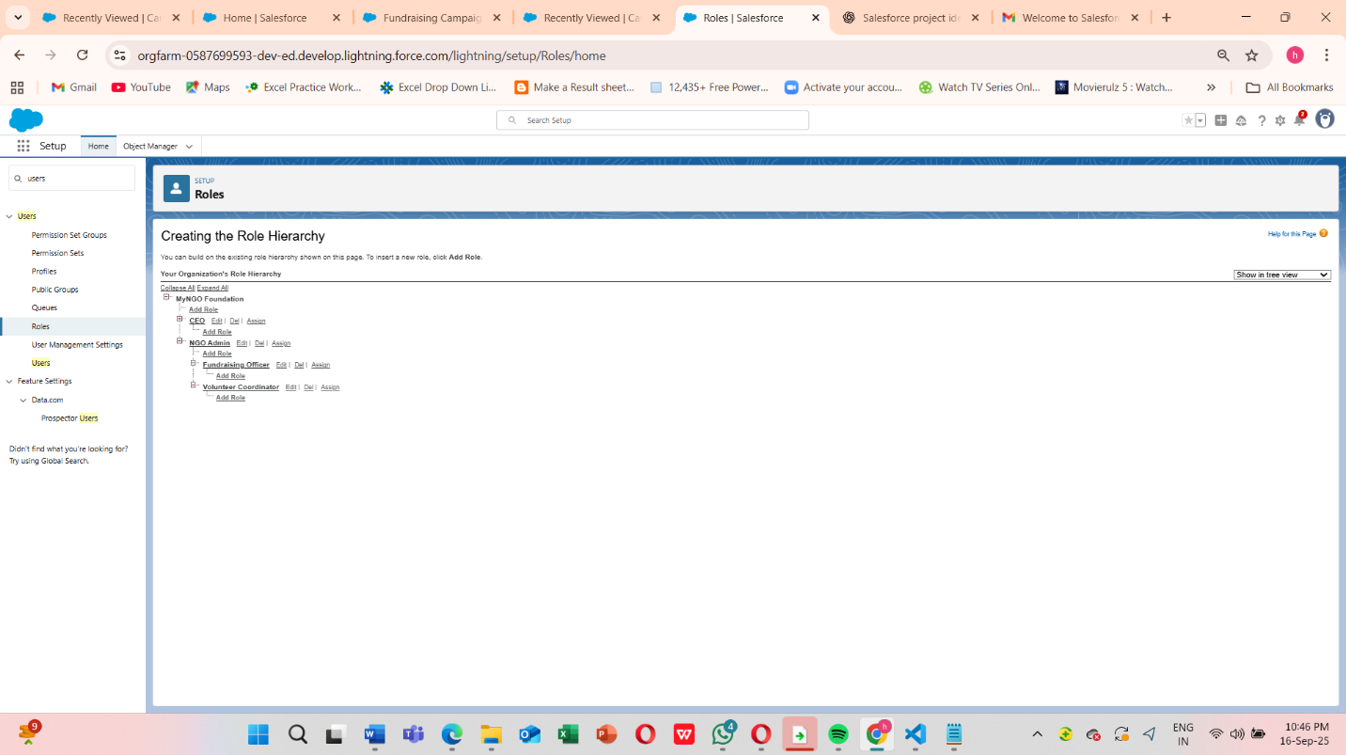

This is Profile detail page with object permissions visible.

**Note** : Before Implementing Permission sets we need to complete the profile process

**Create Permission Sets**

Setup → Permission Sets

**Steps:**

1. Click **New** → Name: Campaign_Access_PS
2. Object Settings → Campaign → Enable Read & Edit access
3. Assign this permission set to your **Fundraising Officer** user

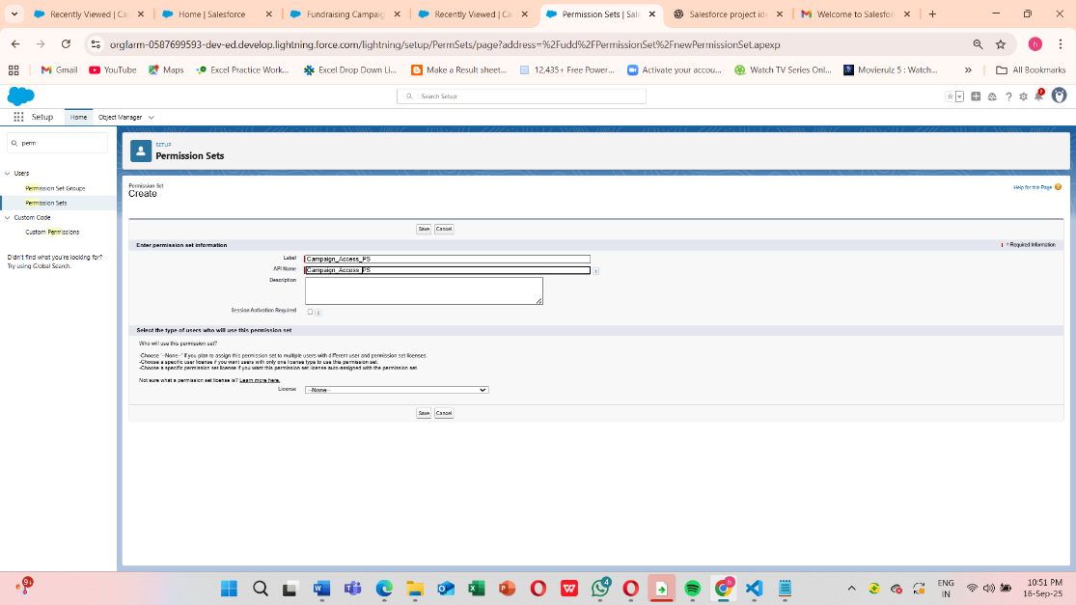I

In Object settings , we see ->

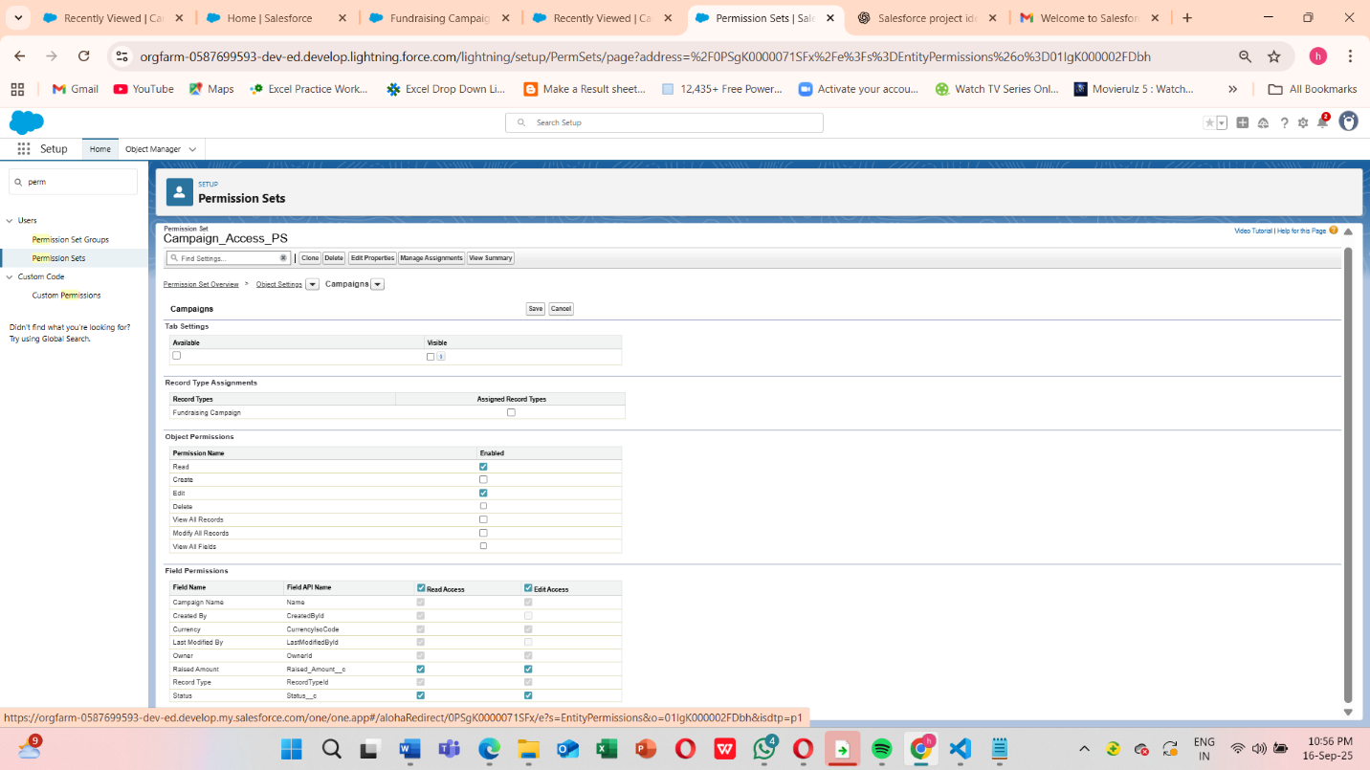

Finally , **Assign Roles to Users**

* Go to **Setup → Users → Users**
* Edit your Officer, Fundraising user → set **Role = Fundraising Officer**
* Save

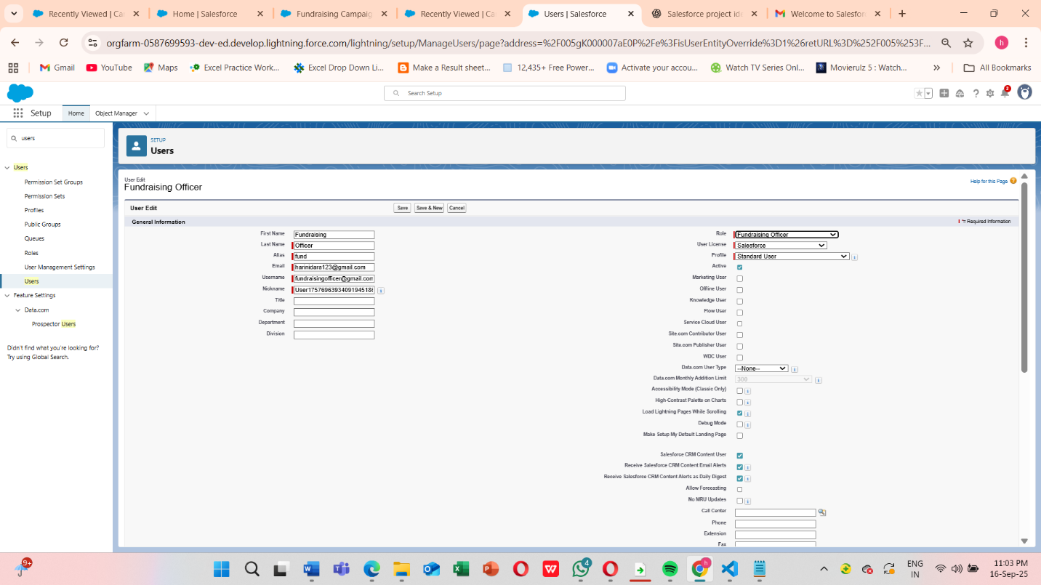

**7.Set OWD (Organization-Wide Defaults)**

Donor & Donation data must be private by default.

* Setup → Sharing Settings
* Set Donor & Donation OWD = **Private**
* Save

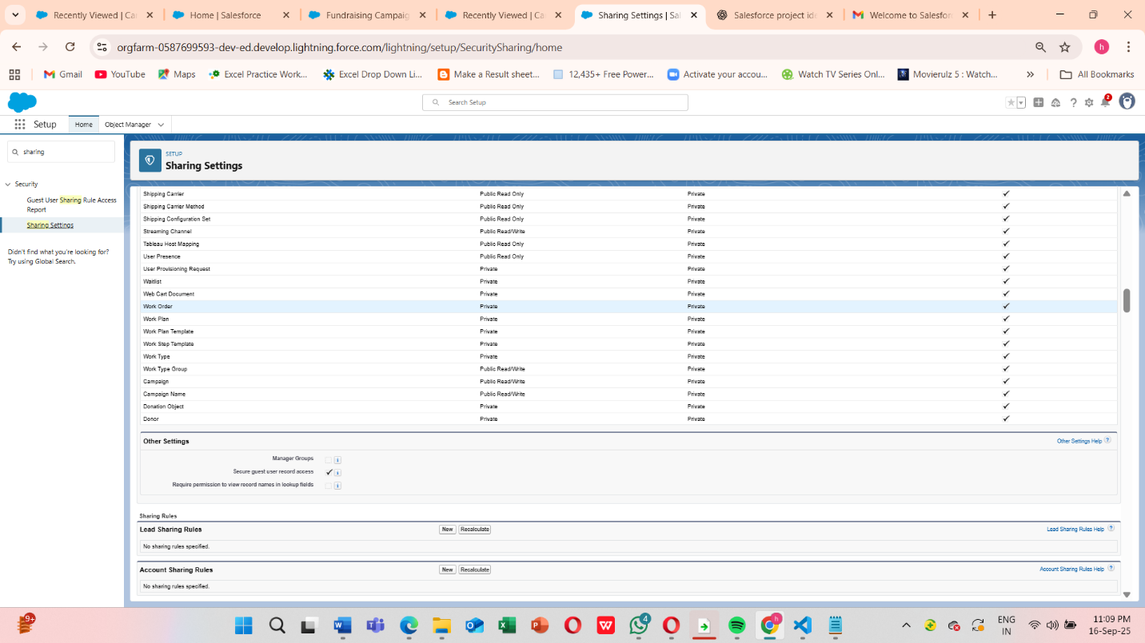



This ensures **donor confidentiality** while allowing collaboration on campaign-related activities

**8.Sharing Rules**

Sharing rules were configured to extend record access where necessary:

* Donations shared with Fundraising Managers (Read/Write)
* Campaigns shared with all volunteers (Read Only)

This balances **security with collaboration**, ensuring that only authorized users can access sensitive donation information.

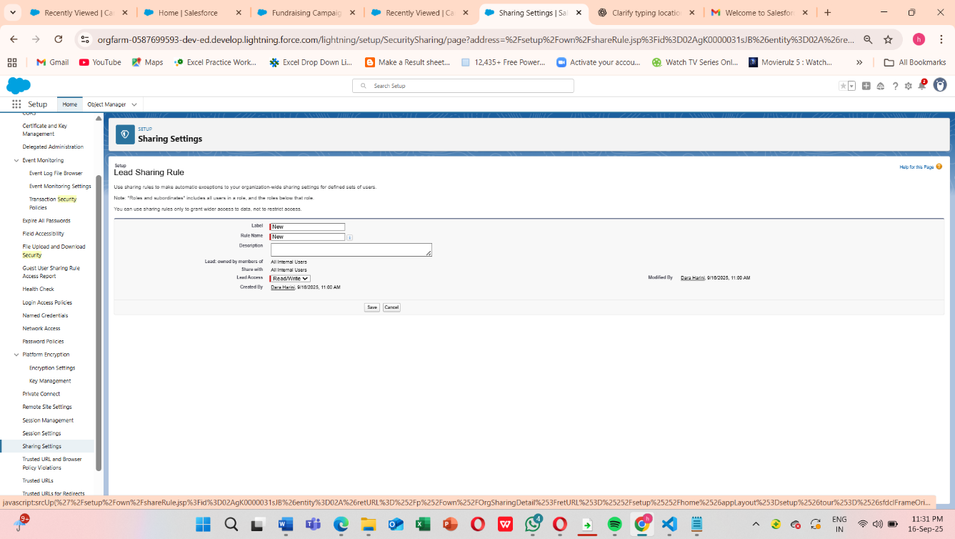

Share Donations with the **Manager role** so they can view all donations

**9.Login Access Policies**

Define’s how users access Salesforce securely.

1. Setup → Security → Login Access Policies
2. Enable Administrators Can Log in as Any User

**Administrator Login Access**

* Enabled the option: **“Administrators Can Log in as Any User.”**
* This allows system administrators to access user accounts temporarily for troubleshooting issues, resetting configurations, or assisting users facing login errors.

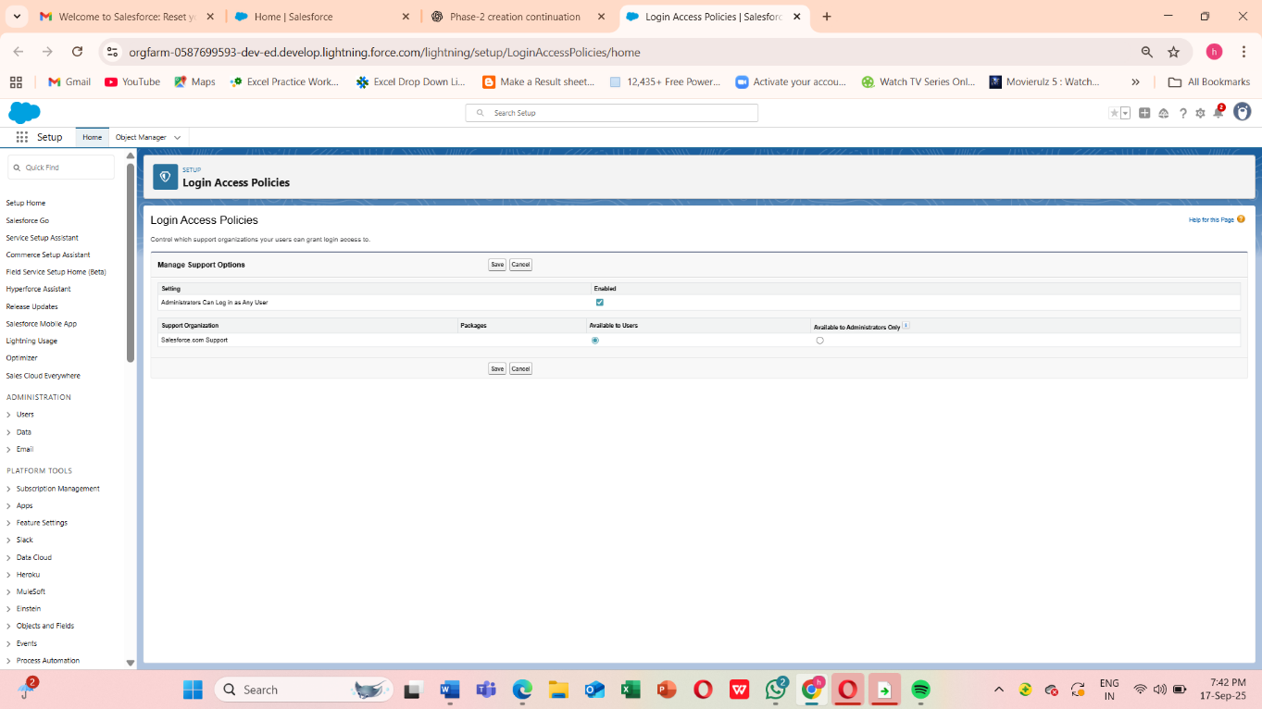

**Define Login Hours for Each Profile:**

**Fundraiser Profile**

* **Monday–Friday:** 8:00 AM → 8:00 PM
* **Saturday & Sunday:** None (to restrict access during off-hours)
* ✅ Why: Fundraisers usually work during business hours, handling donor relationships, campaigns, and donation records.

**Volunteer Profile**

* **Monday–Friday:** 7:00 AM → 9:00 PM
* **Saturday:** 9:00 AM → 6:00 PM
* **Sunday:** None
* ✅ Why: Volunteers may work flexible hours outside regular business timings, but restricting late-night access adds a layer of security.

**Admin Profile**

* **All Days:** 12:00 AM → 11:59 PM (Full Access)
* ✅ Why: Admins need unrestricted access since they may handle system issues or urgent donor support requests anytime.

**Save Settings** once the time slots are entered. Example :

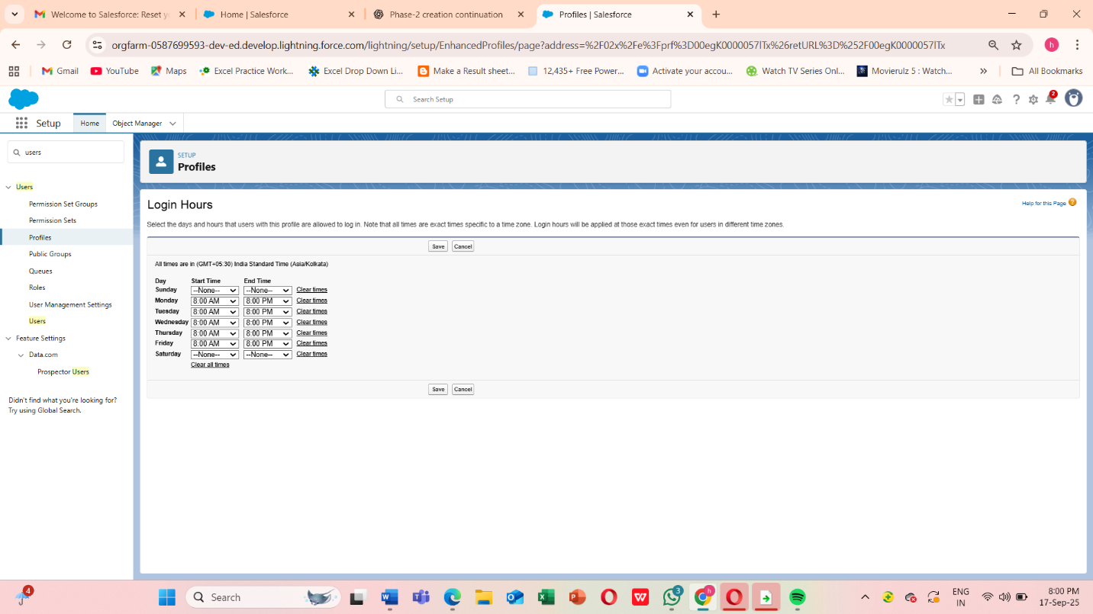

**10. Developer Org Setup**

To safely test and build our **AI-Powered NGO Donation & Impact Management System**, we created and configured a **Salesforce Developer Org**. A developer org acts as a **free sandbox environment** where new features, configurations, and AI functionalities can be built and validated without affecting live donor or campaign data.

Step 1 - Sign up: [https://developer.salesforce.com/signup] or developer.salesforce.com/signup.

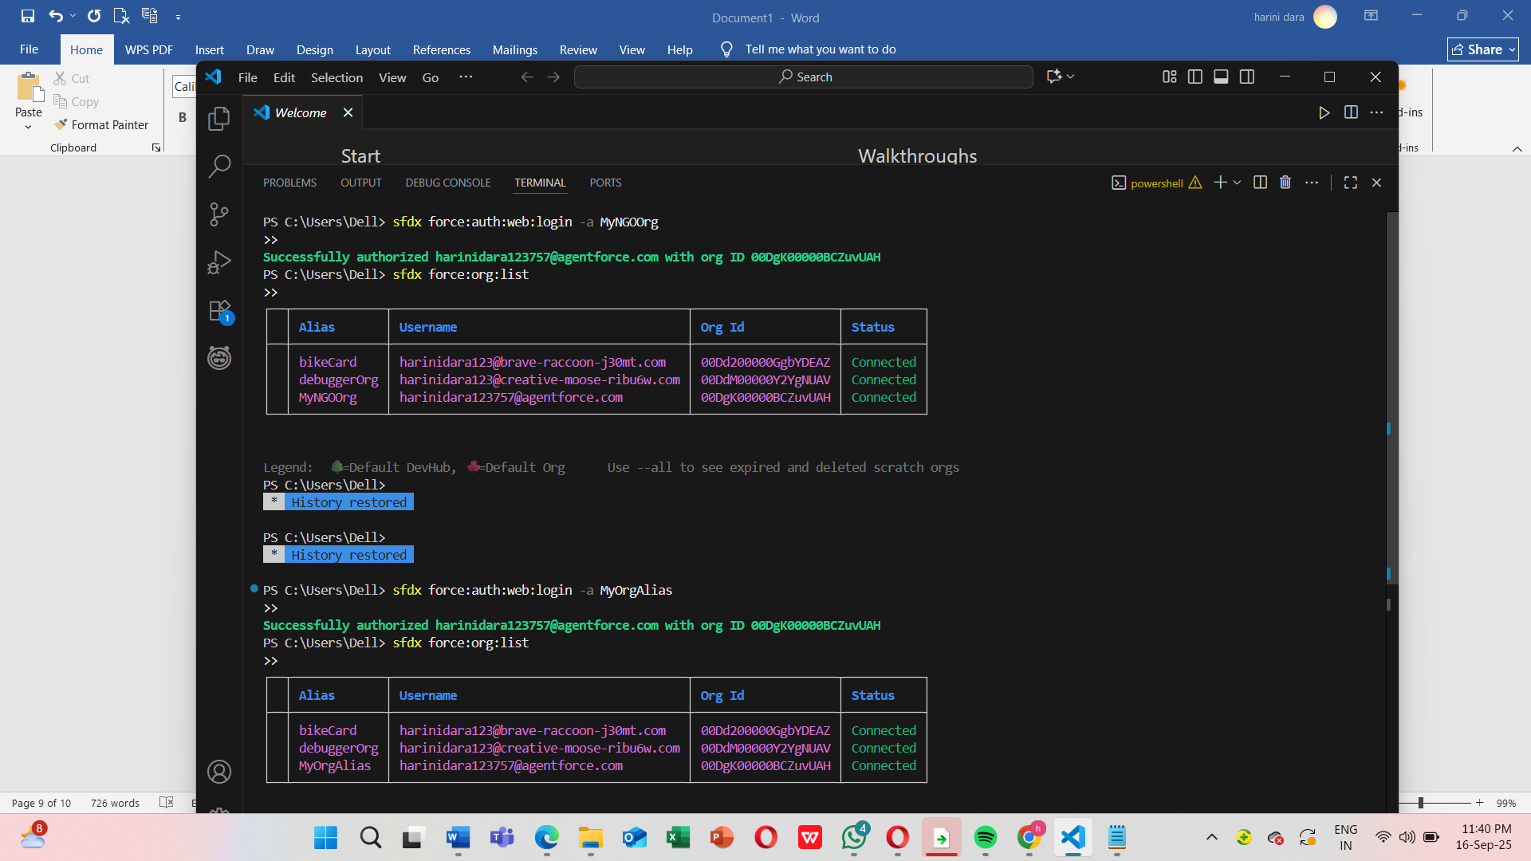

**Connecting Your Org with VS Code**

Since you've already set up your Salesforce org and connected it with VS Code, you can now manage and deploy your metadata locally. Here's how to proceed:

**1. Authenticate Salesforce CLI with Your Org**

If you haven't authenticated yet, run the following command in your VS Code terminal:

**sfdx force:auth:web:login -a MyNGOOrg**

This will open a browser window for you to log in to your Salesforce org.

**2. Retrieve Metadata from Your Org**

To bring your existing objects and fields into VS Code, run:

**sfdx force:source:retrieve -m CustomObject:Donor,CustomObject:Campaign,CustomObject:Donation**

This command fetches the metadata for your Donor, Campaign, and Donation objects.

**3. Make Changes Locally**

* Edit fields, page layouts, or add new components as needed.
* Use VS Code's Salesforce extensions to streamline your development process.

**4. Deploy Changes Back to Salesforce**

After making changes, deploy them back to your org using:

**sfdx force:source:deploy -p force-app/main/default/objects/Donor__c**

**sfdx force:source:deploy -p force-app/main/default/objects/Campaign__c**

**sfdx force:source:deploy -p force-app/main/default/objects/Donation__c**

Step 2 - Finally we can implement Basic Setup

1. Basic Setup

* + Customized Company Information with NGO details.
  + Set up Business Hours, Fiscal Year, and Locale consistent with our main production org.
  + Installed NGO Donation App structure with custom objects:
    - Donations (to capture donor transactions)
    - Campaigns (for fundraising initiatives)
    - Volunteers (to track volunteer engagement)
    - Impact Metrics (to measure project outcomes)

2.AI Experimentation Space

* + Configured the org to test Einstein Prediction Builder for predicting donor retention.
  + Created sample datasets of donors and donations to train and validate AI models.
  + Validated that predictions and reports worked as expected.

3.Testing Security & Access Controls

* + Replicated Profiles, Roles, and Sharing Settings to simulate real NGO scenarios.
  + Tested Login Access Policies (Login Hours and IP Restrictions) in a safe environment.

Due to this

**Risk-Free Testing -** Ensures changes do not disrupt actual donor or campaign operations and **Consistency -** By mirroring production settings, the Developer Org helps validate how changes will perform in real scenarios.

**11.Sandbox Usage**

In a real-world Salesforce Enterprise Edition org, Sandboxes are used for testing and training before deploying to production. However, since our project is implemented in a **Salesforce Developer Edition**, the Sandbox feature is not available.

To simulate this, we used our **Developer Org as a testing environment**. All new configurations, workflows, and AI models were validated here before documenting them for production deployment.

**Conceptual Sandbox Usage in NGO Projects:**

* **Developer Sandbox:** For testing small configurations like workflows and validation rules.
* **Partial Copy Sandbox:** For testing donor and campaign features with sample records.
* **Full Sandbox:** For complete end-to-end testing with a copy of production data.

Even though our edition doesn’t support Sandboxes, the **Developer Org acted as our Sandbox substitute**, allowing us to:

* Safely test donation workflows and security settings
* Validate AI-powered donor retention predictions
* Simulate role-based access for fundraisers and volunteers

**12.Deployment Basics**

Deployment in Salesforce refers to the process of **moving configurations, customizations, and code** from one environment (like a Developer Org or Sandbox) to another (usually Production). For our **AI-Powered NGO Donation & Impact Management System**, deployment ensures that all the tested features — donor management, fundraising campaigns, AI predictions, and role-based security — move safely into the live environment where NGO staff will actually use them.

It clearly shows the process:

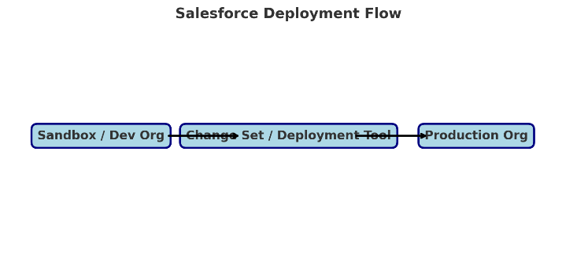

* Start from **Sandbox / Developer Org**
* Move changes using **Change Set / Deployment Tool (ANT, CLI, etc.)**
* Deploy into **Production Org**

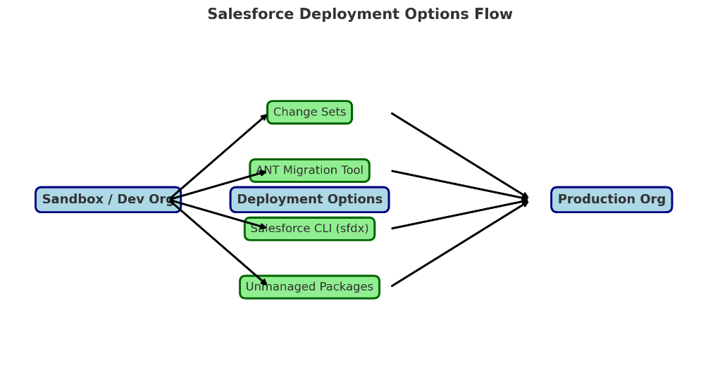

This diagram illustrates how configurations and customizations from the **Sandbox/Developer Org** can be moved to the **Production Org** using different deployment methods:

* **Change Sets** – Best for small, admin-friendly changes (fields, workflows, roles).
* **ANT Migration Tool** – Used for bulk deployments and automation.
* **Salesforce CLI (sfdx)** – Ideal for modern, source-driven deployments with version control.
* **Unmanaged Packages** – Useful in Developer Editions or when sharing modules across NGOs.

In our **AI-Powered NGO Donation & Impact Management System**, this ensures that tested features like donation workflows, AI predictions, and role-based access controls are safely migrated to the live production environment without disrupting ongoing NGO operations.